Year 12 Extension 2 Term 1 2007

Question 1 (15 Marks) Marks

(a) Sketch the curve (x + 1)(y – 2) = 1 2

- Write the function in part (a) in the form y = f(x). Hence, or otherwise, sketch the curve

- y = f(x – 2) 1

- y = 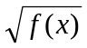 2

- Evaluate

- 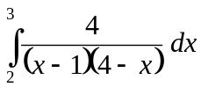 3

(ii) 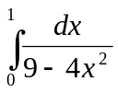 2

- (i) The point P moves so that the sum of its distances from the points (−2, 0) and (2, 0) 4
is 6 units. Prove that the equation of the locus of P is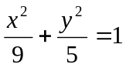.

(ii) Find the eccentricity of this locus. 1

Question 2 (15 Marks) START A NEW PAGE Marks

(a) The hyperbola H is given by the equation 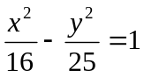.

(i) Write down the equations of the asymptotes. 2

(ii) P is an arbitrary point with coordinates (4secθ, 5tanθ). Show that P lies on H. 2

(iii) Prove that the tangent to H at P has equation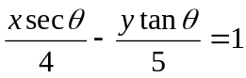. 3

(iv) This tangent cuts the asymptotes in L and M. Prove that LP = PM. 3

Question 2 Continued Marks
- Let n be a positive integer and I_{n} = 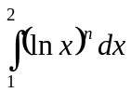.
(i) Prove that I_{n} = 2(ln2)^{n} – nI_{n-1}. 2

(ii) Hence, evaluate 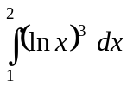. 3

Question 3 (15 Marks) START A NEW PAGE Marks

(a) Find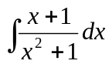. 2

(b) On the attached sheet, you are given the curve of y = f(x).
Sketch neatly on separate diagrams

(i) y = |f(x)| 1

(ii) y = 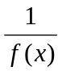 2

(c) (i) Evaluate 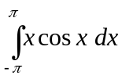. 2

(ii) Evaluate 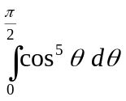. 3

(d) F is the point (4, 0) and d is th line x = 1. M is the foot of the perpendicular from
a variable point P to d, and P moves so that FP = 2PM.

(i) Derive the equation of the locus of P. 3

(ii) Find the acute angle between the asymptotes to the nearest degree. 2

Question 4 (15 Marks) START A NEW PAGE Marks
- Use the substitution t = 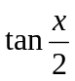 to prove that 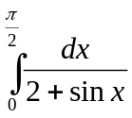 = 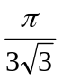. 4

- (i) Show that 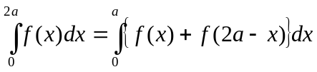. 3

(ii) Hence, or otherwise evaluate 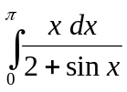. 3

(c) (i) Evaluate 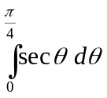. 2
(ii) Hence, show that 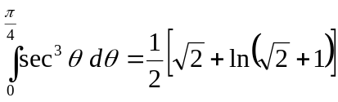 3

~ END OF ASSESSMENT~

Sketch neatly on separate diagrams
y = f(x)

(i) y = |f(x)| 1
y

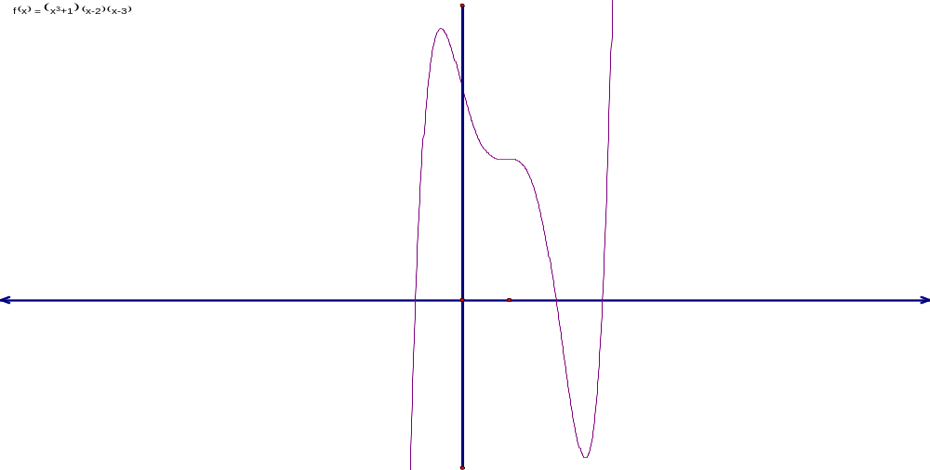
y = f(x)
2
0
x

(ii) y = 2
y

y = f(x)
2
0
x
~SOLUTIONS Year 12 Extension 2 Term 1 Assessment 2007~
Question 1  (a)  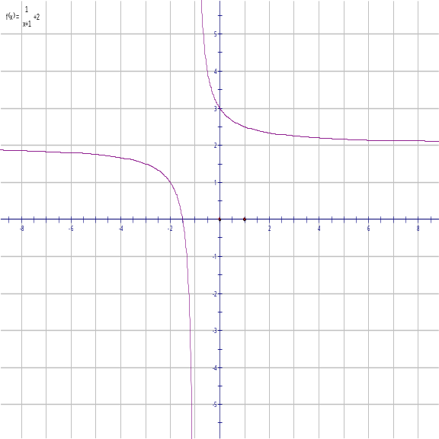 | Asymptotes x = −1 & y = 2➔ ❶ mark  Shape ➔ ❶ Mark
(b) (i)  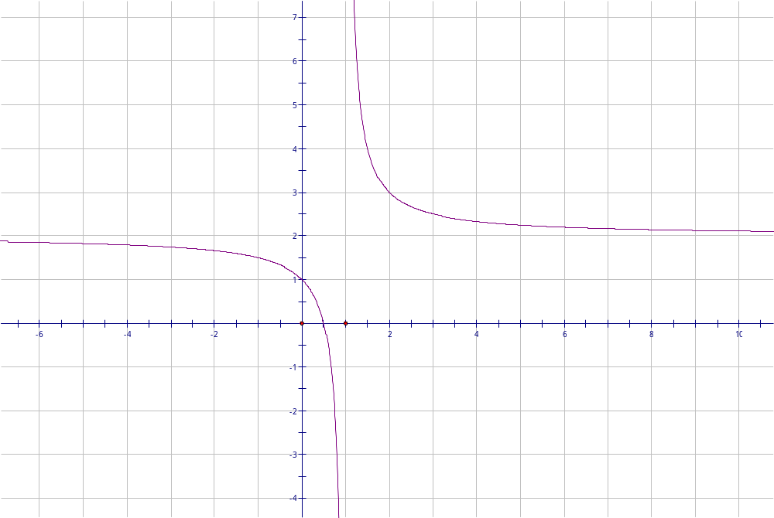 | y = f(x – 2) is a horizontal shift of y = f(x) 2 units to the left. ➔ ❶ Mark  (Asymptotes at y = 2 & x = 1)
(ii)  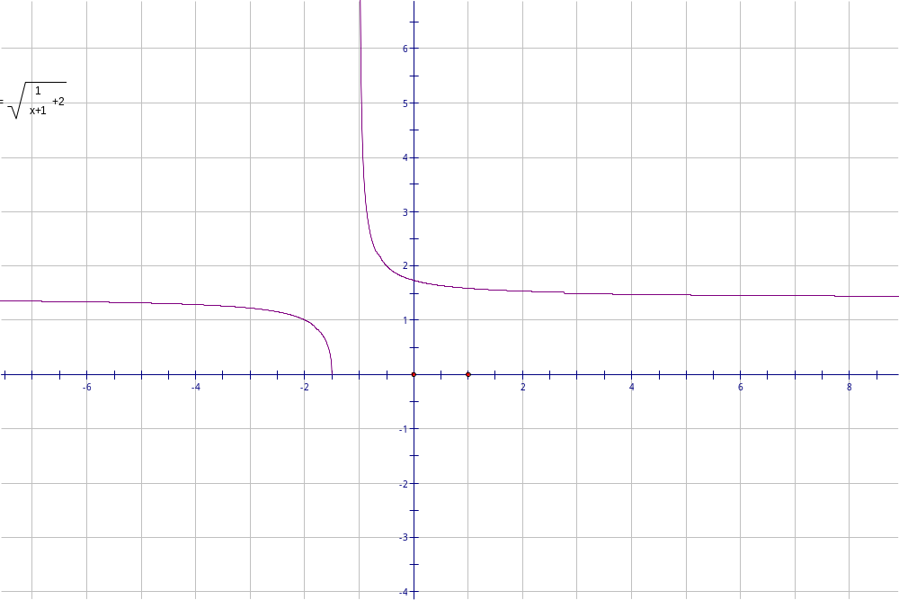 | y =  Asymptote at x = 1 & y = ➔ ½ Mark  y – intercept = &  x – intercept = −1.5➔ ❶ Mark  No graph below x – axis ➔½ Mark  Shape is relatively similar to the original function ∴ no marks awarded
Q1 (c)  (i)  = 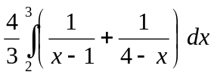  By Partial Fractions  = 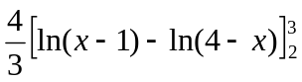  = 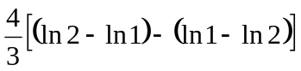  = 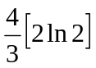 = 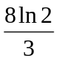  (ii)  = 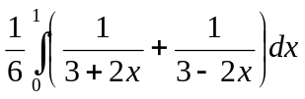  = 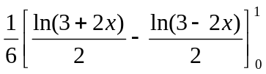  = 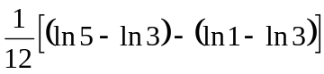  = 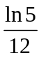  (d) (i) P is (x , y) then by data  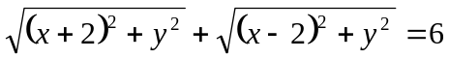  i.e. 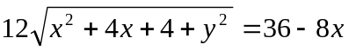  ∴ 9(x² – 4x + 4 + y²) = 81 – 36x + 4x²  ∴ 5x² + 9y² = 45 ➔  (ii) Using b² = a²(1 – e²) since locus is an ellipse where a = 3 and b =  , we get  e = . | Correct values of A and B ➔ ❶ Mark  Correct integration ➔ ❶ Mark  Correct answer ➔ ❶ Mark  This is not a inverse Trigonometry Question!.  No marks awarded if used incorrect method.  Correct use of partial fractions & integration➔ ❶ Mark  Correct evaluation ➔❶ Mark  ➔❶ Mark  ➔❶ Mark  ➔❶ Mark  ➔❶ Mark  ➔❶ Mark

Question 2  (a) (i) Eqn. of asymptotes 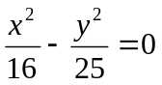  ∴ y = 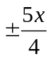  (ii) If P is (4secθ, 5tanθ) then  LHS = 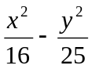  = 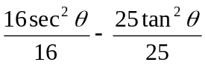  = tan²θ + 1 – tan²θ  = 1 = RHS  ∴ P lies on hyperbola H.  (iii) 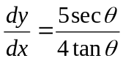 at P.  ∴ eqn. of tangent at P is  y – 5tanθ = 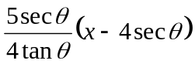  4tanθy – 5x secθ = 20(tan²θ – sec²θ)  ∴  (iv)tangent cuts y = 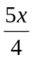when  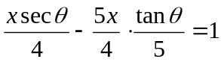  ∴ x = 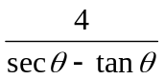 and y = 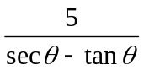.  ∴ L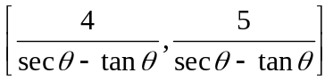  Tangent cuts y = 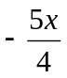at  M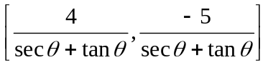  If P is the midpoint of LM then LP=PM.  ∴ x− coordinate of midpoint of LM  = 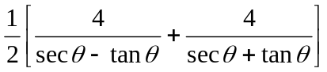  = 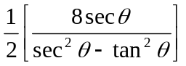  = 4secθ.  y− coordinate of midpoint of LM  = 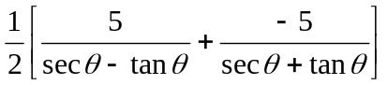  =5tanθ.  ∴ P is the midpoint if LM.  ∴ LP=PM  (b) (i) I_{n} =  = 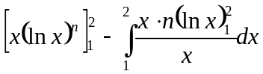  = 2(ln2)^{n} – nI_{n-1}  (ii) I₃ = 2(ln2)³ – 3I₂  = 2(ln2)³ – 3[2(ln2)² – 2I₁]  Now I₁ = 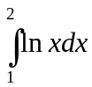  = 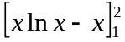  = 2ln2 – 2 – 0 + 1  = 2ln2 – 1  ∴ I₃ = 2(ln2)³ – 6(ln2)² + 12ln2 – 6. | ➔❶ Mark  ➔❶ Mark  ➔❶ Mark  Showing LHS = RHS ➔❶ Mark  Correct differential➔❶ Mark  Correct eqn. of tangent➔❶ Mark  Correct rearrangement to get required answer ➔❶ Mark  Correct coordinates of L ➔ ½ Mark  Coordinates of M ➔ ½Mark  Correctly finding x and y coordinates of midpoint  Or using distance formula & conclusion ➔❷ Marks  ➔❷ Marks  ➔❶ Mark  ➔❶ Mark  ➔❶ Mark

Question 3  (a) = 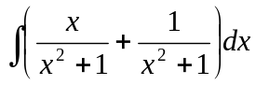  = 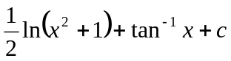  (b) See next page  (c) (i) Let f(x)= x cosx then f(−x) = −xcos(−x) = −f(x)∴ it’s an odd function.  ∴ 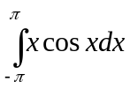 = 0  (ii) = 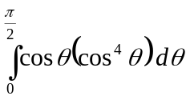  = 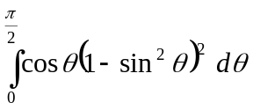  = 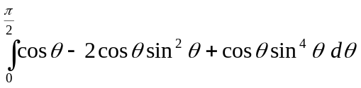  = 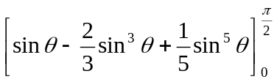  = 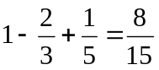  (d) (i) PF = 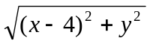  PM = |x – 1| ∴ PF² = 4 PM²  ∴ x² – 8x + 16 + y² = 4x² – 8x + 4  ∴ 3x² – y² = 12 ➔ 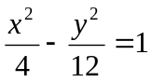  (ii) asymptotes y = 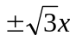  ∴ line y =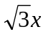makes an angle of rads with positive x – axis and line y =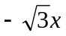makes an angle of 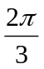rads. ∴ acute angle is rads. | ➔❶ Mark  ➔❶ Mark  - ➔❶ Mark  - ➔❷ Mark  Showing it’s an odd function ➔❶ Mark  Answer = 0 ➔❶ Mark  ➔❶ Mark  Correct integration➔❶ Mark  Correct answer ➔❶ Mark  ➔❶ Mark each for PF and PM (by definition)  ➔ ½ for squaring both sides & expanding  ➔ ½ for correct locus.  Correct equations of asymptotes➔❶ Mark  Correct answer with some explanation ➔❶ Mark

Q3 (b) (i) y = |f(x)| 1
y
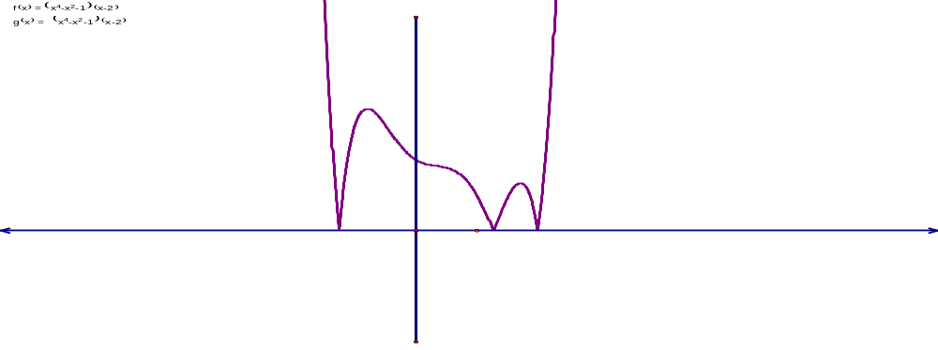
x

(ii) y = 2
y
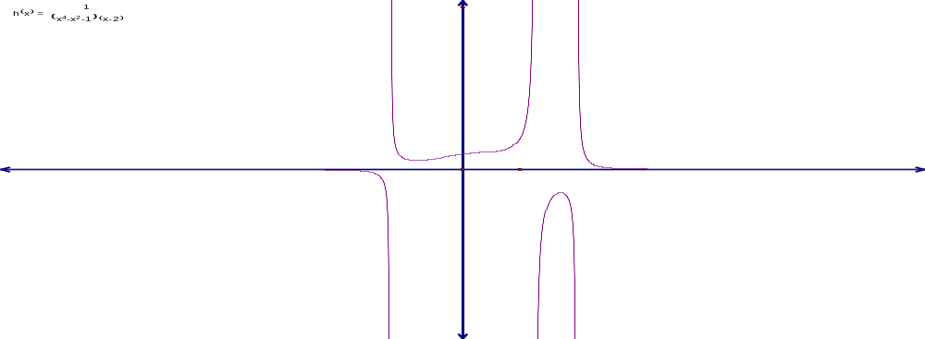
x
Question 4  (a)  [when x = 0, t = 0 and x =  then t = 1]  = 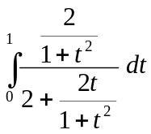  = 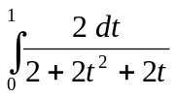 = 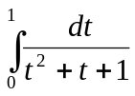  =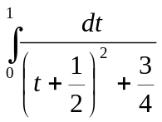  =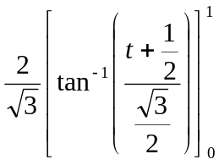=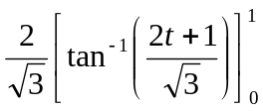  =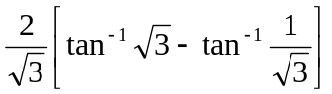=  (b) (i) 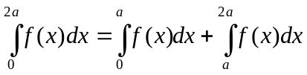  Now 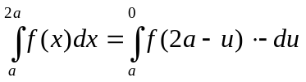  =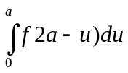 = 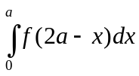  Since the definite integral is independent of the variable.  Hence 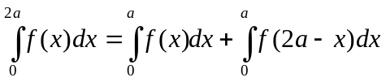  = 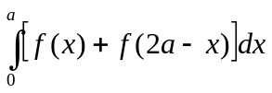  (ii)  = 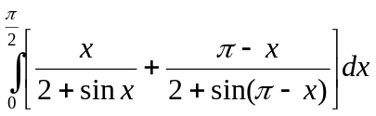  = 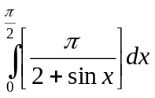since sin x = sin(π – x)  = 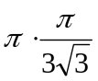 from part (a)  = 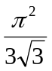  (c) (i) = 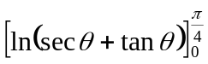  = 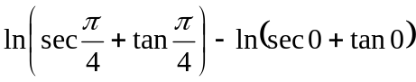  = 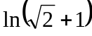  (ii) 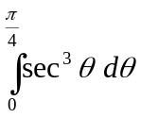=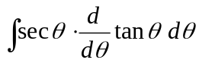  = 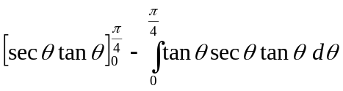  = 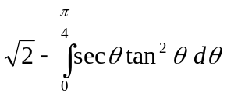  = 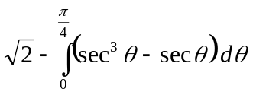  ∴ 2= 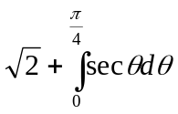  = 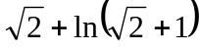  ∴ | Change of variables & correct t substitution  ➔❷ Marks  ➔❶ Mark  Correct integration & substitution➔❶ Mark  ➔❶ Mark  Let u = 2a – x then dx = −du & x = a → u = a & x = 2a → u = 0. ➔❶ Mark  ➔❶ Mark  Correct use of part (i) ➔❶ Mark  ➔❶ Mark  ➔❶ Mark  Correct integration➔❶ Mark  Correct answer➔❶ Mark  ➔❶ Mark  ➔❶ Mark  ➔❶ Mark using part (i)

